Eric A Dockery

09/12/13

Assignment #1

1. Modify the applet in the Einstein example from lecture notes so that the circle is centered at the bottom right hand corner of the rectangle.

For this problem the logic is to take the circle object and change its position using the page.drawOval(75, 65, 20, 20); on the page and moving its location to the other corner of the drawRect (60, 80, 225, 30);// rectangle. By moving page.drawOval(75, 65, 20, 20); to page.drawOval( 275, 100, 20, 20); the expected output should draw the Oval (circle) in the bottom right hand corner of the rectangle. The location of the circle is determined by the rectangles dimensions. The rectangle starts at 60, 80 and the length is 225 with the width of 30 making the end points of the circle at the right point 285, 110. We want the circle to be centered and because it is 20 pixels long and 20 pixels wide we cut the dimensions in half for the oval then subtract that from the right end point of the rectangle in order to get the center difference.

View the Screen shots below for the solution:

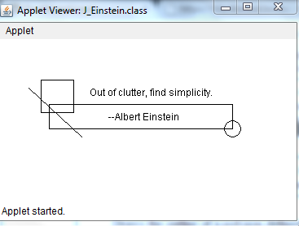

1. Programming project 2.8 of Chapter 2 on page 109. This assignment wants the user to write an application that reads values representing a time duration in hours, minutes, and seconds and then prints the equivalent total number of seconds.

To solve this problem I will have the user prompted for each interval store each in a variable and preform the correct mathematical operation to convert each answer into seconds. Those seconds will then be added together and a total of the time will be displayed for the user.

Screenshots:

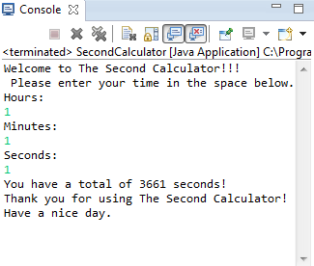

1. Programming project 2.10 of Chapter 2 on page 109. This assignment wants the user to write an application that determines the value of the coins in a jar and prints the total in dollars and cents. Read integer values that represent the number of quarters, dimes, nickels, and pennies.

In order to solve this problem I make the program read each integer given by the user and use the input times the value of the coin. It will then sum up the coins worth and display the value on the screen.

Error Screen Shot:

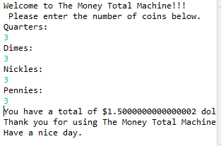

Incorrectly multiplied the pennies. Didn’t stop the double from rounding incorrectly.

Screen Shots:

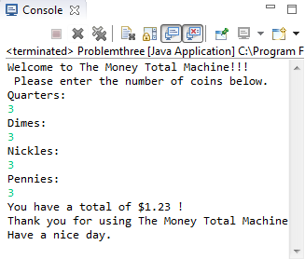

1. Programming project 2.12of Chapter 2 on page 110. This assignment wants use to write an application that prompts for and reads an integer representing the length of a square’s side, then prints the square’s perimeter and area.

In order to solve this problem you must first understand how to calculate the area and perimeter of a square. Area of a square is the multiple of a side times itself. The Perimeter of the square is 4 times the side length. Then after these values are calculated then the program will display the totals for each.

Screen Shots:

